1

#include <iostream>

using namespace std;

int main ()

{

int a=0,b=0;

cin>>a>>b;

cout<<((float)(a+b)/2)<<endl;

return 0;

}

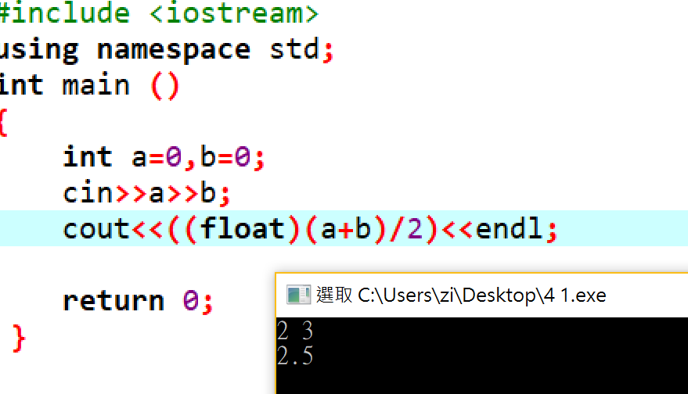

2 (A)

#include <iostream>

#include <math.h>

using namespace std;

int main ()

{

unsigned short LED=0;

bool tmp;

for (int i=0;i<8;i++)

{

cout<<"輸入第"<<i+1<<"顆LED值 (由右至左)";

cin>>tmp;

LED=LED+tmp\*pow(2,i);

}

cout<<"LED value:"<<LED;

return 0;

}

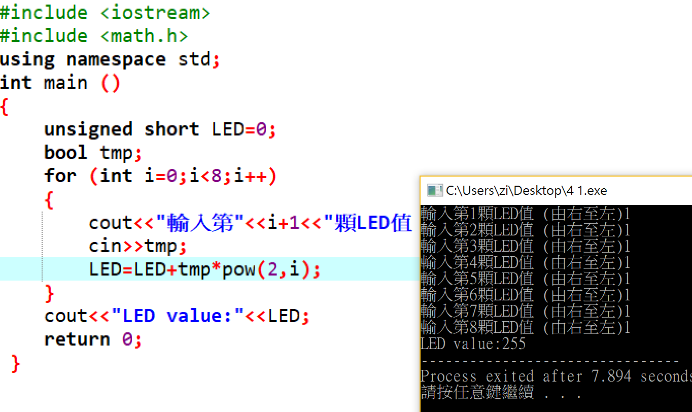

2 (B) (C) (D)

#include <iostream>

using namespace std;

int main ()

{

//B

short LED=0x5555; //0101010101010101=0x5555

cout<<hex<<LED<<endl;

//C

LED=0xAAAA; //1010101010101010=0xAAAA

cout<<hex<<LED<<endl;

//D

LED=~LED;

cout<<hex<<LED;

return 0;

}

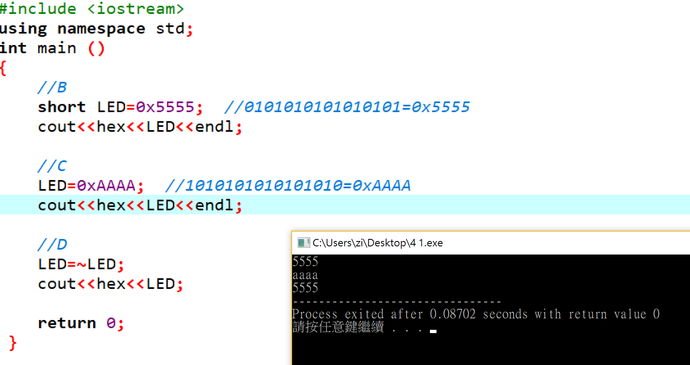

3

#include <iostream>

using namespace std;

int main ()

{

unsigned int a1,a2,b1,b2,o1,o2;

cin>>hex>>a1;

cin>>hex>>a2;

cin>>hex>>b1;

cin>>hex>>b2;

if ((o2<a2)||(o2<b2)) //發生 overflow

{

o2=a2+b2;

o1=a1+b1+1;

}

else

{

o2=a2+b2;

o1=a1+b1;

}

cout<<hex<<o1<<' '<<hex<<o2;

return 0;

}

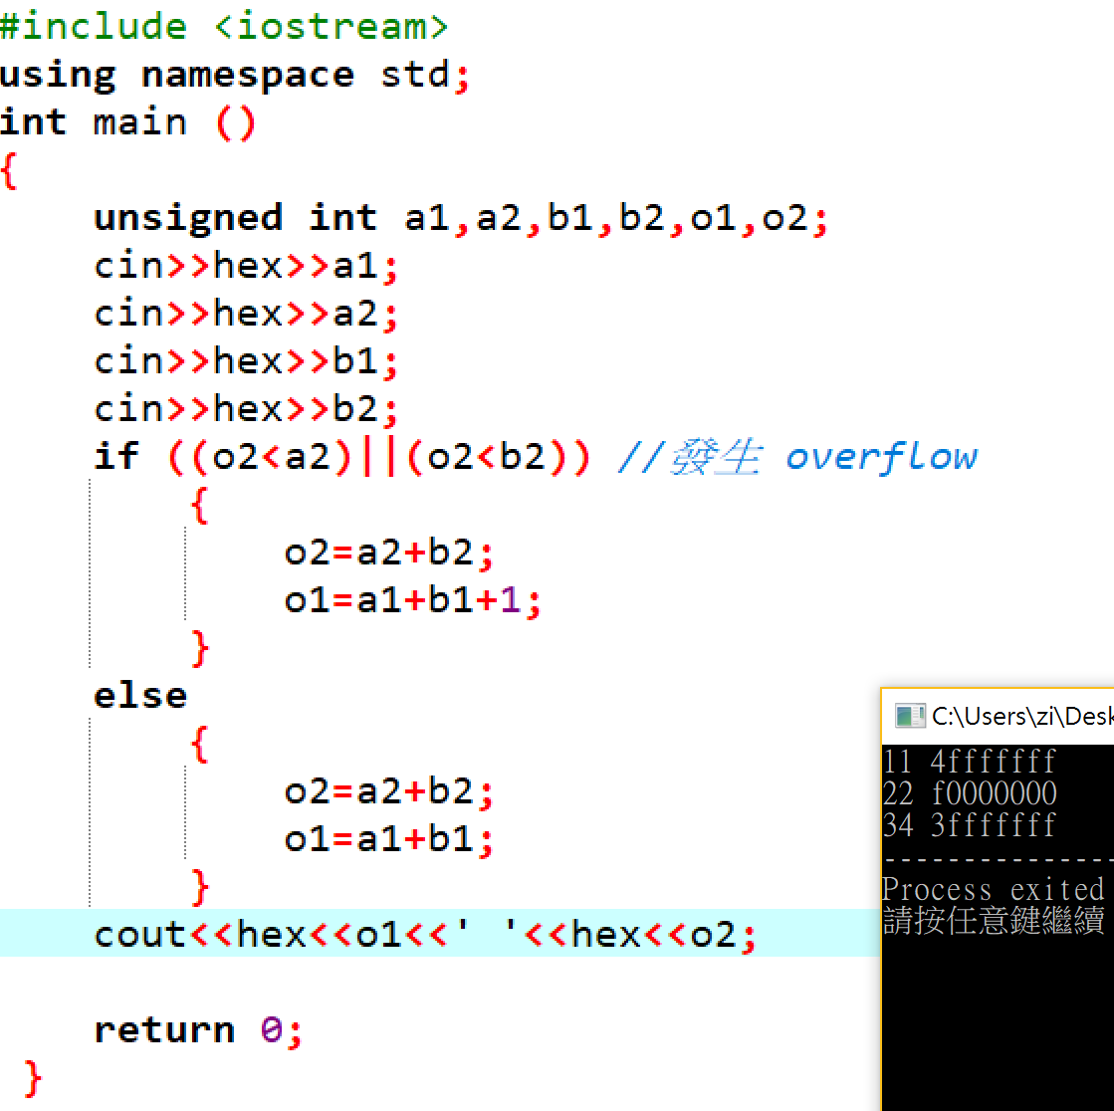

4

#include <iostream>

using namespace std;

int main ()

{

int a=0,b=0;

cin>>a>>b;

cout<<"(a++)+b ="<<(a++)+b<<endl;

cout<<"(++a)+b ="<<(++a)+b<<endl;

cout<<"(a++)+(b++) ="<<(a++)+(b++)<<endl;

cout<<"(++a)+(++b) ="<<(++a)+(++b)<<endl;

cout<<"a+(b++) ="<<a+(b++)<<endl;

return 0;

}

